Chapter 15, Problem 50.

Use the Laplace transform to solve the differential equation

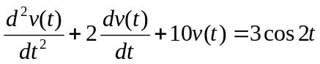

subject to v(0) = 1 and dv(0)/dt = -2.

